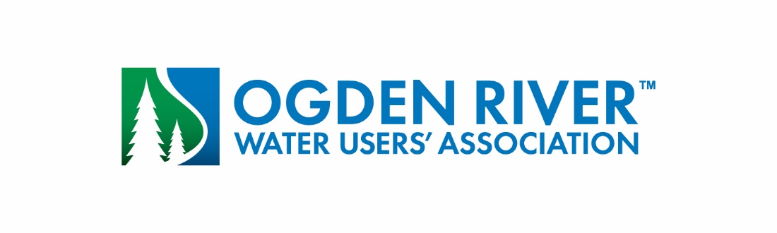

**Meeting of the Board of Directors**

**September 9, 2025 @ 2:00 p.m.**

# AGENDA

1. Review and approval of minutes of August 12, 2025
2. Water Report

3. Manager’s Report

4. Other business

5. Approval and payment of bills

6. Adjourn