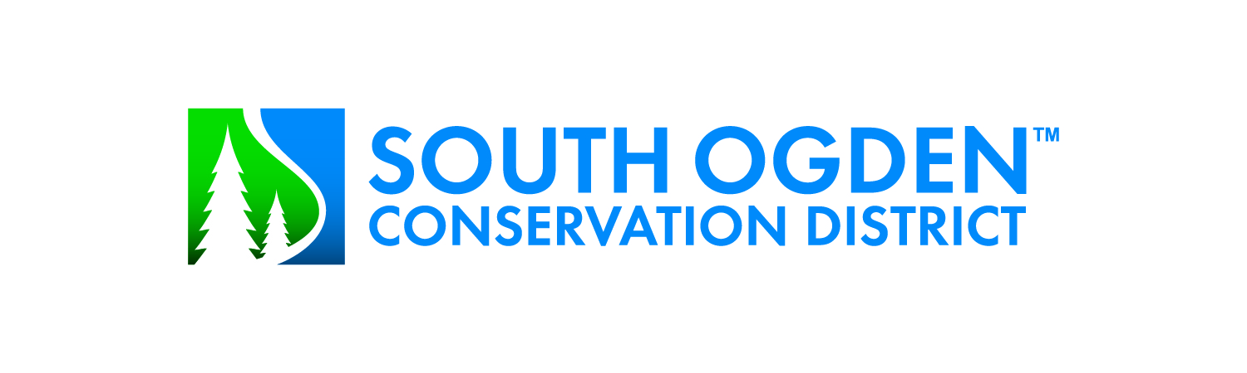
Meeting of the Board of Trustees
April 9, 2024 @ 1:00 p.m.

Agenda

1. Review and approval of minutes of March 12, 2024
2. Water report
3. Construction update

4. Discuss Weber Basin’s future rate increases (4 years)

5. General Manager’s report

6. Board member questions and comments

7. Approval and payment of bills – review/action

8. Adjourn

